***SUZANNE GALER***

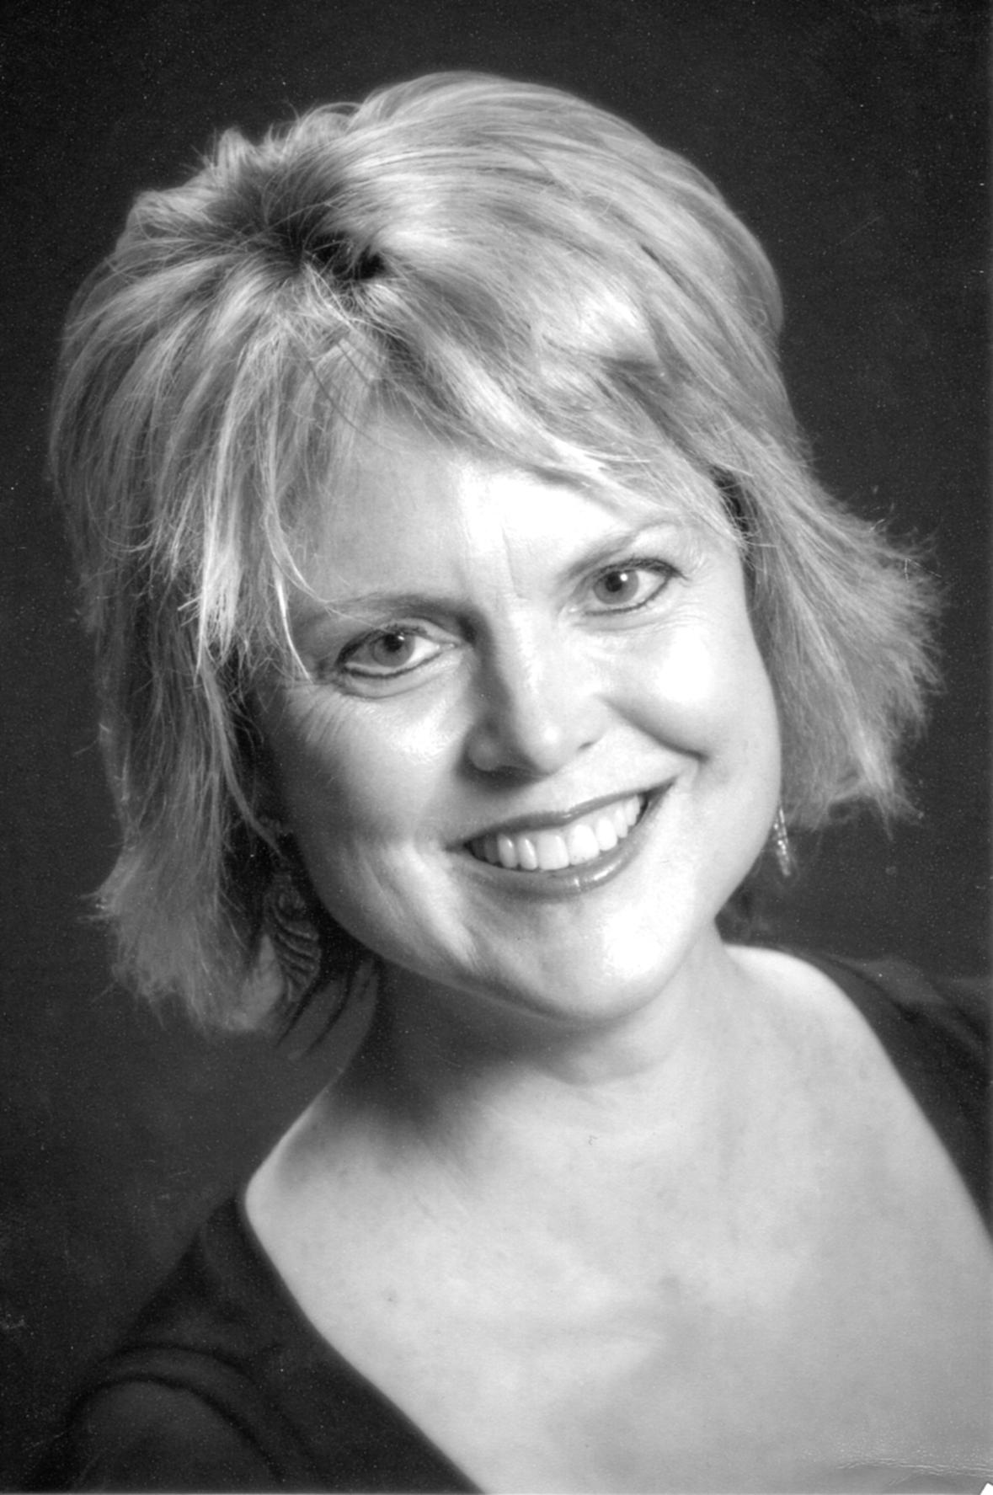

**CROSS-OVER ARTIST/ AGMA**

**Cell 336-430-8640 Work: Palm Beach Atlantic University E-mail**

[**http://www.youtube.com/watch?v=HtangsauRI4**](http://www.youtube.com/watch?v=HtangsauRI4)

[**suzgaler@gmail.com**](mailto:suzgaler@gmail.com)

**Musical Theatre**

Candide, Bernstein excerpts Indian River Pops, Palm Beach Gardens Owen Seward, Conductor, 2013

*Musical of Musicals*, Madame von Starr Theatre Huntsville, Huntsville, Alabama Leslie Bofill, Director 2012

Jan Mulder Pops Orchestra, Artist Broadcast: Public Television Jan Mulder, Conductor 2010

*Wizard of Oz*, Glinda Carolina Theatre, Greensboro, NC Mitchell Sommers, Director

*Pajama Game*, Gladys Ramsdell Theatre, Manistee, Michigan Jackie Carnez, Director

*King and I*, Anna Ramsdell Theatre, Manistee, Michigan Tom Richert, Director

*Princess Pat*, Princess di Montaldo Comic Opera Guild, Ann Arbor, MI Adam Aceto, Director

*Have A Heart*, Peggy Comic Opera Guild, Ann Arbor MI Adam Aceto, Director

*Oh Boy*! Lou Ellen Comic Opera Guild, Ann Arbor MI Adam Aceto, Director

*Very Good Eddie*, Madame Matroppo Comic Opera Guild, Ann Arbor MI Adam Aceto, Director, 200

*The Red Mill*, Tina Comic Opera Guild, Ann Arbor MI Adam Aceto, Director , 2002

Dance: Tap I, Tap II, Ballet, Modern, Jazz

Additional talents: French Horn, Piano-Vocal Entertainer, Autoharp

Height: 5’8

**Oratorio**

Lord Nelson Mass Bethesda Chapel by the Sea, Palm Beach Geoffrey Holland, Conductor 2013

Fauré Requiem Royal Ponciana Chapel , Palm Beach, Florida Jack Jones, Conductor, 2013

*Bach Cantata #78*, Wir Eiland Royal Ponciana Chapel, Palm Beach, Florida Jack Jones, Conductor, 2013

Handel’s *Messiah*  Ars Nova Company, Fayetteville, Tennessee Joe Stephenson, Conductor 2012 Poulenc *Gloria*  Huntsville, Chorus , Huntsville, Alabama Billy Orton, Conductor, 2009

*Mount of Olives*, Seraph Ars Nova , Fayetteville, Tennessee Joe Stephenson, Conductor 2010

*Dixit Dominus*, Handel Kensington Consort, Greensboro, North Carolina James Wilson, Conductor, 2007

*Carmina Burana*, Orff Lake Charles Symphony, Florida Masterworks William Kushner, Conductor

*A New Creation*, Clausen Calvin College Oratorio Society, Michigan Renee Clausen, Conductor

*King David*, Honnegeur Midland Odessa Symphony, Texas Don Jaeger, Conductor

**Role/Opera Company/Location** **Conductor/Date:**

*Ballad of Baby Doe*, First Friend Ars Nova Company, Huntsville, AL Ron Harris, Director 2010

Die Zauberflöte, Queen Ars Nova Company, Huntsville, AL Joe Stephenson, Director, 2009

Rome Festival, Rome, Italy Fritz Maraffi, Conductor

*Hansel and Gretel*, Dew Fairy Indianapolis Opera, Indiana James Carraher, Conductor

*Suor Angelica*, Mother Abbess Bel Canto NorthWest, Portland, Oregon Dottie Danner, Director

*Ariadne Auf Naxos*, Najade Shreveport Opera, Louisiana Peter Leonard, Conductor

Turn of the Screw, Governess Inspiration Point, Eureka Springs, Arkansas Carroll Freeman, Director

*Carmen*, Frasquita Il Piccolo Opera, New York City Camille Coppola, Director

*Anina*, *La Traviata* Rockland Opera, Long Island Lyric, NYC Alexander Rom, Director

*King David*, Honnegeur Midland Odessa Symphony, Texas Don Jaeger, Conductor

**Competition**

New York Vocal Artists, 1st Place Carnegie Hall and CAMI Hall Debuts NYC Brian Douglas, Director

**Education**

State University of New York Master of Music Stony Brook, New York